High Level

Documentation

Content:

1. Introduction
   1. Why this high level documentation
   2. Scope
   3. Definitions
2. General Description
   1. Product Persepctive
   2. Problem Statement
   3. Proposed solution
   4. Further improvements
   5. Technical Requirements
      1. Tools used
3. Design Details
   1. Process flow
      1. Model Training and evaluation
      2. Deployment Process
   2. Event Log
   3. Error Handling
   4. Performance
   5. Reusability
   6. Application Compatibility
   7. Resource Utilization
   8. Deployment
4. Dashboards
5. Conclusion

**Abstract:**

At present the insurance is a flourishing industry, with several national and international players. The insurance sector was opened up for private participation on the ground that in spite of enormous contributions made by the public sector to expand the coverage and spread awareness about insurance, the interests of the consumers would be better served. Our model builds upon the micro-level contract structure issued by the insurer, and aims to capture the risk exhibited by the aggregation of policyholders. This distinguishes from traditional risk theory that uses random-walk-type model, and also enhances risk evaluation in actuarial pricing practice by incorporating the dynamic arrivals of policyholders in emerging cost analysis. The simulation methodology relies on our model’s connection to infinite-server queues with non-homogeneous cost under heavy traffic. We will construct a sequential importance sampler with provable efficiency, along with large deviations asymptotics.

**Introduction:**

1. Why this High Level Documentation?

The purpose of this HLD documentation is to add the necessary details to the current project description to represent a suitable modeling code. This document is also intended to help detect contradictions prior to coding, and can be used as a reference manual for how the modules interact at a high level.

The HLD will:

* Present all the design aspects and define them in details.
* Describe the user interface being implemented.
* Describe hardware and software interface.
* Describe the preformance requirements.
* Include the design features and architecture of the projects.
* List and describe the non-funcrional attributes like:
  + Security
  + Reliability
  + Maintainability
  + Application compatibility
  + Portability
  + Reusability
  + Resource utilization

1. Scope:

The HLD document present the structure of the system, such as database architcture, application architecture (layers), application flow (Navigation), and technology architecture. The HLD used non-technical to mildly-technical terms which should be understandable to the administrators of the system.

1. Definitions:

|  |  |
| --- | --- |
| TERM | DESCRIPTION |
| 1. IPP | Insurance Premium Prediction |
| 1. Database | Cassandra |
| 1. IDE | Integrated Development Environment |
|  |  |

**General Description:**

The main purpose of developing this HLD is for easy identification of model and its core part.

1. **Product Perspective:**

The IPP is Premium is a machine learning based prediction model which will help the people to estimate which insurance is to be selected based on their requirements.

1. **Problem statements:**

The goal of this project is to give people an estimate of how much they need based on their individual health situation. After that, customers can work with any health insurance carrier and its plans and perks while keeping the projected cost from our study in mind. This can assist a person in concentrating on the health side of an insurance policy rather than the ineffective part.

1. **Proposed Solution:**

To this IPP the solution that we are going to propose “A web based model that will easily help to predict the type of insurance customer is looking for.” The following are the use cases:

* **Enter all the basic details and by looking at the model it automatically predict which type of insurance a person is looking for.**

1. **Further improvements:**

In future we can also improve the model just not only in prediction but also it will download the details in pdf format for the customer reference.

1. **Technical Requirements:**

This document will directly address all the technical requirements for developing the sophisticated model.

* 1. Tools used:

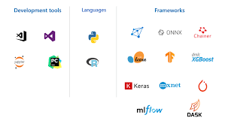

**Design Details:**

This sheet will clearly specify the detail design of the project.

1. **Process Flow: The architecture is shown below**

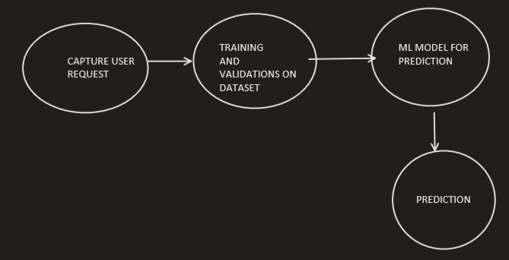

1. **Model training and evaluation:**

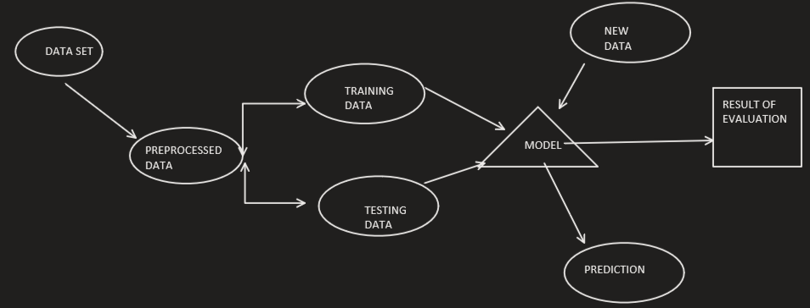

1. **Deployment process:**

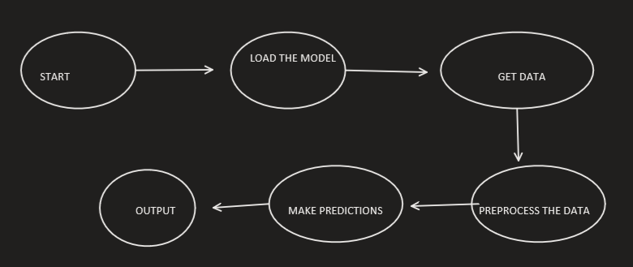

**Event Log:**

The system should log every event so that the user will know what process is running internally.

Initial step by stem description:

1. The system should identify at what step logging is required.
2. The system should be able to log each and every system flow.
3. Developer can choose the logging method and also choose database logging or file logging as well.
4. System should not hand even after too many loggings. Logging just because we can easily debug the issues as logging is mandatory to do.

**Error Handling:**

Error should be encountered; an explanation will be displayed if any error occurred at any point of execution.

**Performance:**

The IPP is a technique which will help the bank employee and user to identify any fraud transaction has taken place. So that whatever the necessary action needed to be taken can be easily taken by the bank or card holder itself.

**Reusability:**

The code written and the component used should have the ability to be reused without problem.

**Application Compatibility:**

The different components for this project will be used using python as an interface between them. Each component will have its own task to perform, and it is the task of python to perform and ensure the proper transfer of information.

**Resource Utilization:**

When any task is preformed, it will likely use all the processing power available until that function is finished.

**Deployment:**

The deployment can be done on any platform using CASSANDRA.

**Conclusion:**

The IPP is a technique which will help the bank employee and user to identify any fraud transaction has taken place. So that whatever the necessary action needed to be taken can be easily taken by the bank or card holder itself.